SCHOOL OF INFOCOMM DIPLOMA IN MOBILE SOFTWARE DEVELOPMENT
Name of Company: muvee Technologies
Training Period: 18th September 2017 - 2nd February 2018
Student’s Email Address: 15017523@rp.edu.sg
Course/Year: Diploma in Mobile Software Development / 2016
Name of Student: Nur Haziq Bin Nahar Student ID. 15017523

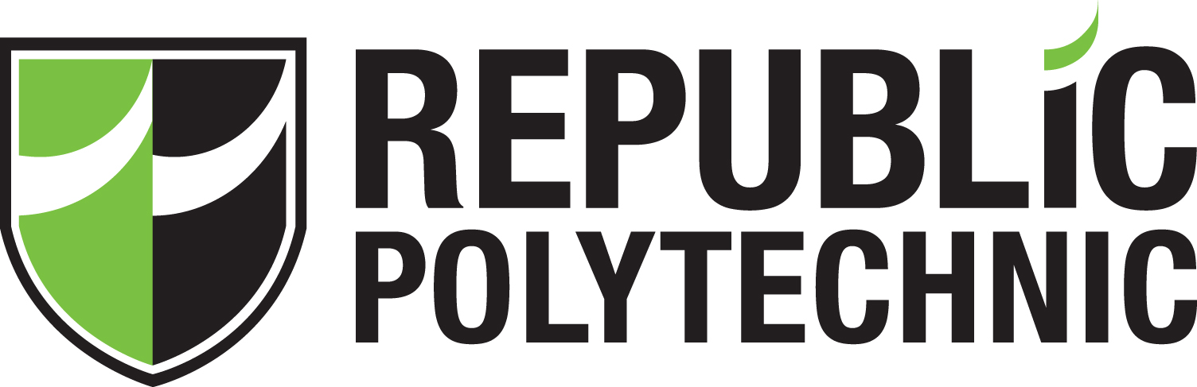

INDUSTRY IMMERSION PROGRAMME (IIP) REPORT

TABLE OF CONTENTS
 | PAGE
ACKNOWLEDGMENTS | 3
EXECUTIVE SUMMARY | 3
I INTRODUCTION | 3
II BACKGROUND INFORMATION OF ORGANISATION | 3
III THE TRAINING AND WORK ASSIGNMENTS (Main Text) | 4
IV REFLECTIONS | 5
V CONCLUSIONS | 6
REFERENCES | 6
APPENDIXES | 6
- Internship Report Clearance Form | 6
- Weekly Log Sheet Form | 6
- Project Proposal | 6

ACKNOWLEDGEMENTS
My android team members, Nimalan, Gopal and Park Jung Min. For always advising how to go about certain obstacles in my tasks. Also my supervisor Harsha, from muvee who shared his thoughts on my project proposal.
EXECUTIVE SUMMARY
This report describes, in depth, my internship experience at muvee Technologies for over a span for more than 5 months. It explains my role, duty, what I have learnt and reflections I have at the end of this internship.
I INTRODUCTION
Here at muvee Technologies, I am assigned as an Enterprise Mobility Developer to work in the Android team. My internship duration was from 18th September 2017 till the 2nd February 2018. Along with another 1 or 2 Android team members, we work on a major (in progress) project. The project is about a year and a half years old. Throughout my 5 months, I explored more about the front end coding of an application as well as back end development.
II BACKGROUND INFORMATION OF ORGANISATION
muvee Technologies specializes in video editing software and products founded in 1999. In 2001 muvee released a video editing software for PCs, the award winning autoProducer. In 2005, muvee worked with Nikon CoolPix S5 to create an automatic slideshow engine for the digital camera. In 2014, they launched the world’s first mobile video editing app for action camera users, the Action Studio, followed by another application for both iOS and Android users, creating dramatic slomo video sequences, ReAction.
muvee has worked with a myriad of leading brands of IT devices such as Samsung, LG, HTC, Sony, Alcatel, Android and iOS application stores. muvee has shipped on over 750 million devices.

III THE TRAINING AND WORK ASSIGNMENTS
Over the span of 20 weeks, I was given a number of tasks. The majority of my tasks was to work on AlbumStory. AlbumStory is a smart mobile application that analyses all the photos taken by the camera of the device, which then creates an automatic album based on various parameters like photo quality, time, location information, etc. This is targeted at major mobile companies and photo book makers across the globe.
In the beginning of my internship, I spent a good 2 weeks familiarising myself with the code and trying to see how the logic of the engine works. The project is heavily modularized and these modules are shared between AlbumStory and VideoStory. VideoStory is an app which creates automatic videos, with music, from photos taken by your phone camera. I contributed some changes to VideoStory engine from time to time but my main focus was AlbumStory.
While contributing code for AlbumStory, I had to familiarise myself with their version control mechanism which was Git. They host their code online on BitBucket and use SourceTree to push their changes to the cloud. It is not something very new, but it was crucial for me to know how to upload correctly.
By the time I came in, the project was already about a year into development and it had all the basic functions and layouts. The lead designer would feed me the new layouts, with blueprints as well as resource files and I had to commence work with them. This is where I learnt the most, with a little guidance from a team mate, and a lot of research, I could deliver the layouts. To this day I have delivered about 3 or 4 UI redesigns for different modules for a pretty dense application.
From the front-end coding, I also learnt how to bind data to the User Interface. I learn about threading, storing data, and mostly making use of the Exif data stored in images.
This brings me to my other mini tasks, whenever I am not busy coding front end layouts. I researched more about High Dynamic Range (HDR) images. I was tasked to find out how to tell apart a HDR image from another by looking at the binary data of images and how to spot HDR in programming as well. After 2 to 3 weeks’ worth of research with photos captured on different Android phones, I could make a working demo application.
IV REFLECTIONS
I learn a lot of new things whenever I get to code. Sometimes, my team mate will advise me how to improve my code and that is when I independently research on my own. Other times, they are already some code done in other applications that I can make use of.
So, this internship has been rich in new knowledge, particularly in Android front end development, for me. Every day, I encounter obstacles along the way. I will always find a way to solve it, or at least I seek my team members for advice. I research on Stackoverflow on my own and try to be resourceful. I think I handled the obstacles in coding pretty well. However, I was not as good at researching as I am at coding. There is a lot of improvement for here. I do have the researching skills, well taught in school. However, when given something which I am alienated by, I am completely lost. Almost helpless.
At the same time, I also get some free time to really make sure I absorb these knowledges. So, whenever I can, I would make demo applications where I apply what I have just learnt, for
future references.
Taking a step back from coding, in the office I have learnt a lot about the culture in the IT industry or specifically, small companies like muvee. From my perspective, although globally know, this is a small company, in terms of size as compared to a big company like NTUC. Perhaps muvee may not be the best example of how an IT company works but I believe it is a good company and I can take home a lot of lessons as I end my internship.
I see that delivering assignments is important and work ethic plays a huge part in ensuring how assignments are delivered, maintaining a good relationship between an employee and supervisor.
I think there is a lot to work on my work ethic since I am still stuck in my comfort zone when doing work.
All in all, I think I am suited for this line of industry. I can start by equipping myself with more knowledge in skills before I can start a career.

V CONCLUSIONS
In summary, I have learnt in depth about front end coding, briefly on back end coding as well as Exif data on images. It was an eye opener to the industry which I look forward to be a part of, in the future, and it better prepared me for a career similar to this role of my internship.
REFERENCES
https://en.wikipedia.org/wiki/Muvee_Technologies
APPENDIXES
- Internship Report Clearance Form
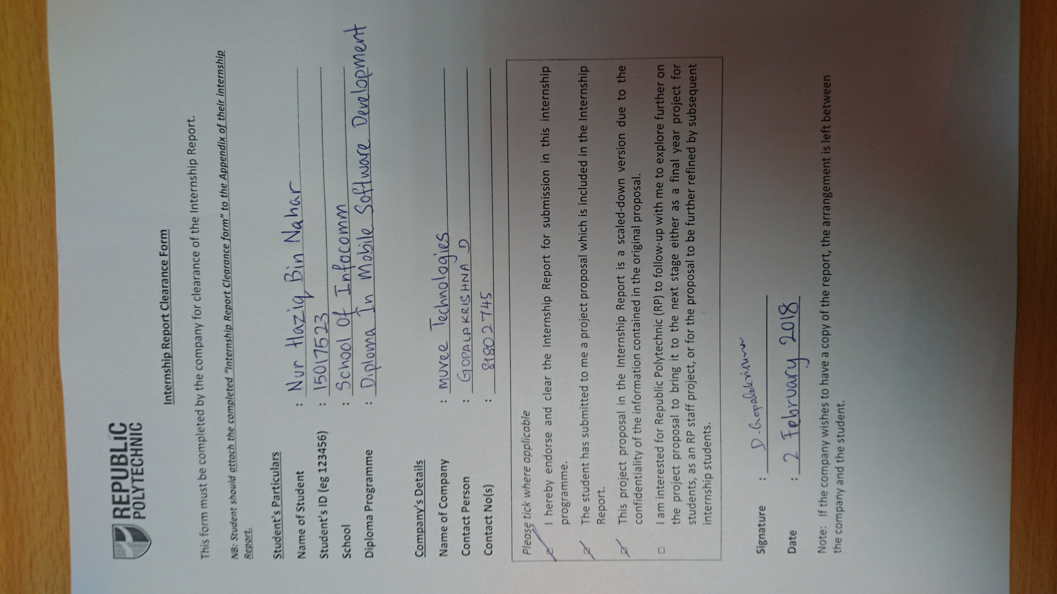
- Weekly Log Sheet Form

- Project Proposal
